## Module 6 Student Questions

## Observation Experiment: T2 Relaxation - Guided Inquiry Questions

1. First, let's initialize our spin state and then knock the spins down into the x-y plane using a hard-90° pulse. Is there any MR signal decay? Explain how you came to your conclusion.
2. In the upper-left menu, click on 'Relaxation: Off', and you can see that both 'T1' and 'T2' are set to infinity. Why is having both 'T1' and 'T2' set to infinity the same as having the relaxation turned 'off'?
3. Now change the 'T2' value to some finite value (while leaving 'T1' at infinity). Describe what happens to the net nuclear magnetization vector, [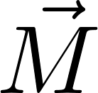](https://www.codecogs.com/eqnedit.php?latex=%5Cvec%7BM%7D#0), and sketch the resulting plot of |Mxy| and Mx.
4. Describe how T2 relaxation appears to cause the MR signal to decay.
5. Given the description of what causes T2* relaxation versus T2 relaxation, which do you think is always the larger value, T2 or T2*? Why?
6. Below is some FID data acquired from a mineral oil sample in a 0.5-Tesla magnetic field. What is the approximate T2* value for this sample? *Hint: You want to find the time when the signal reaches 37% of its initial amplitude.*

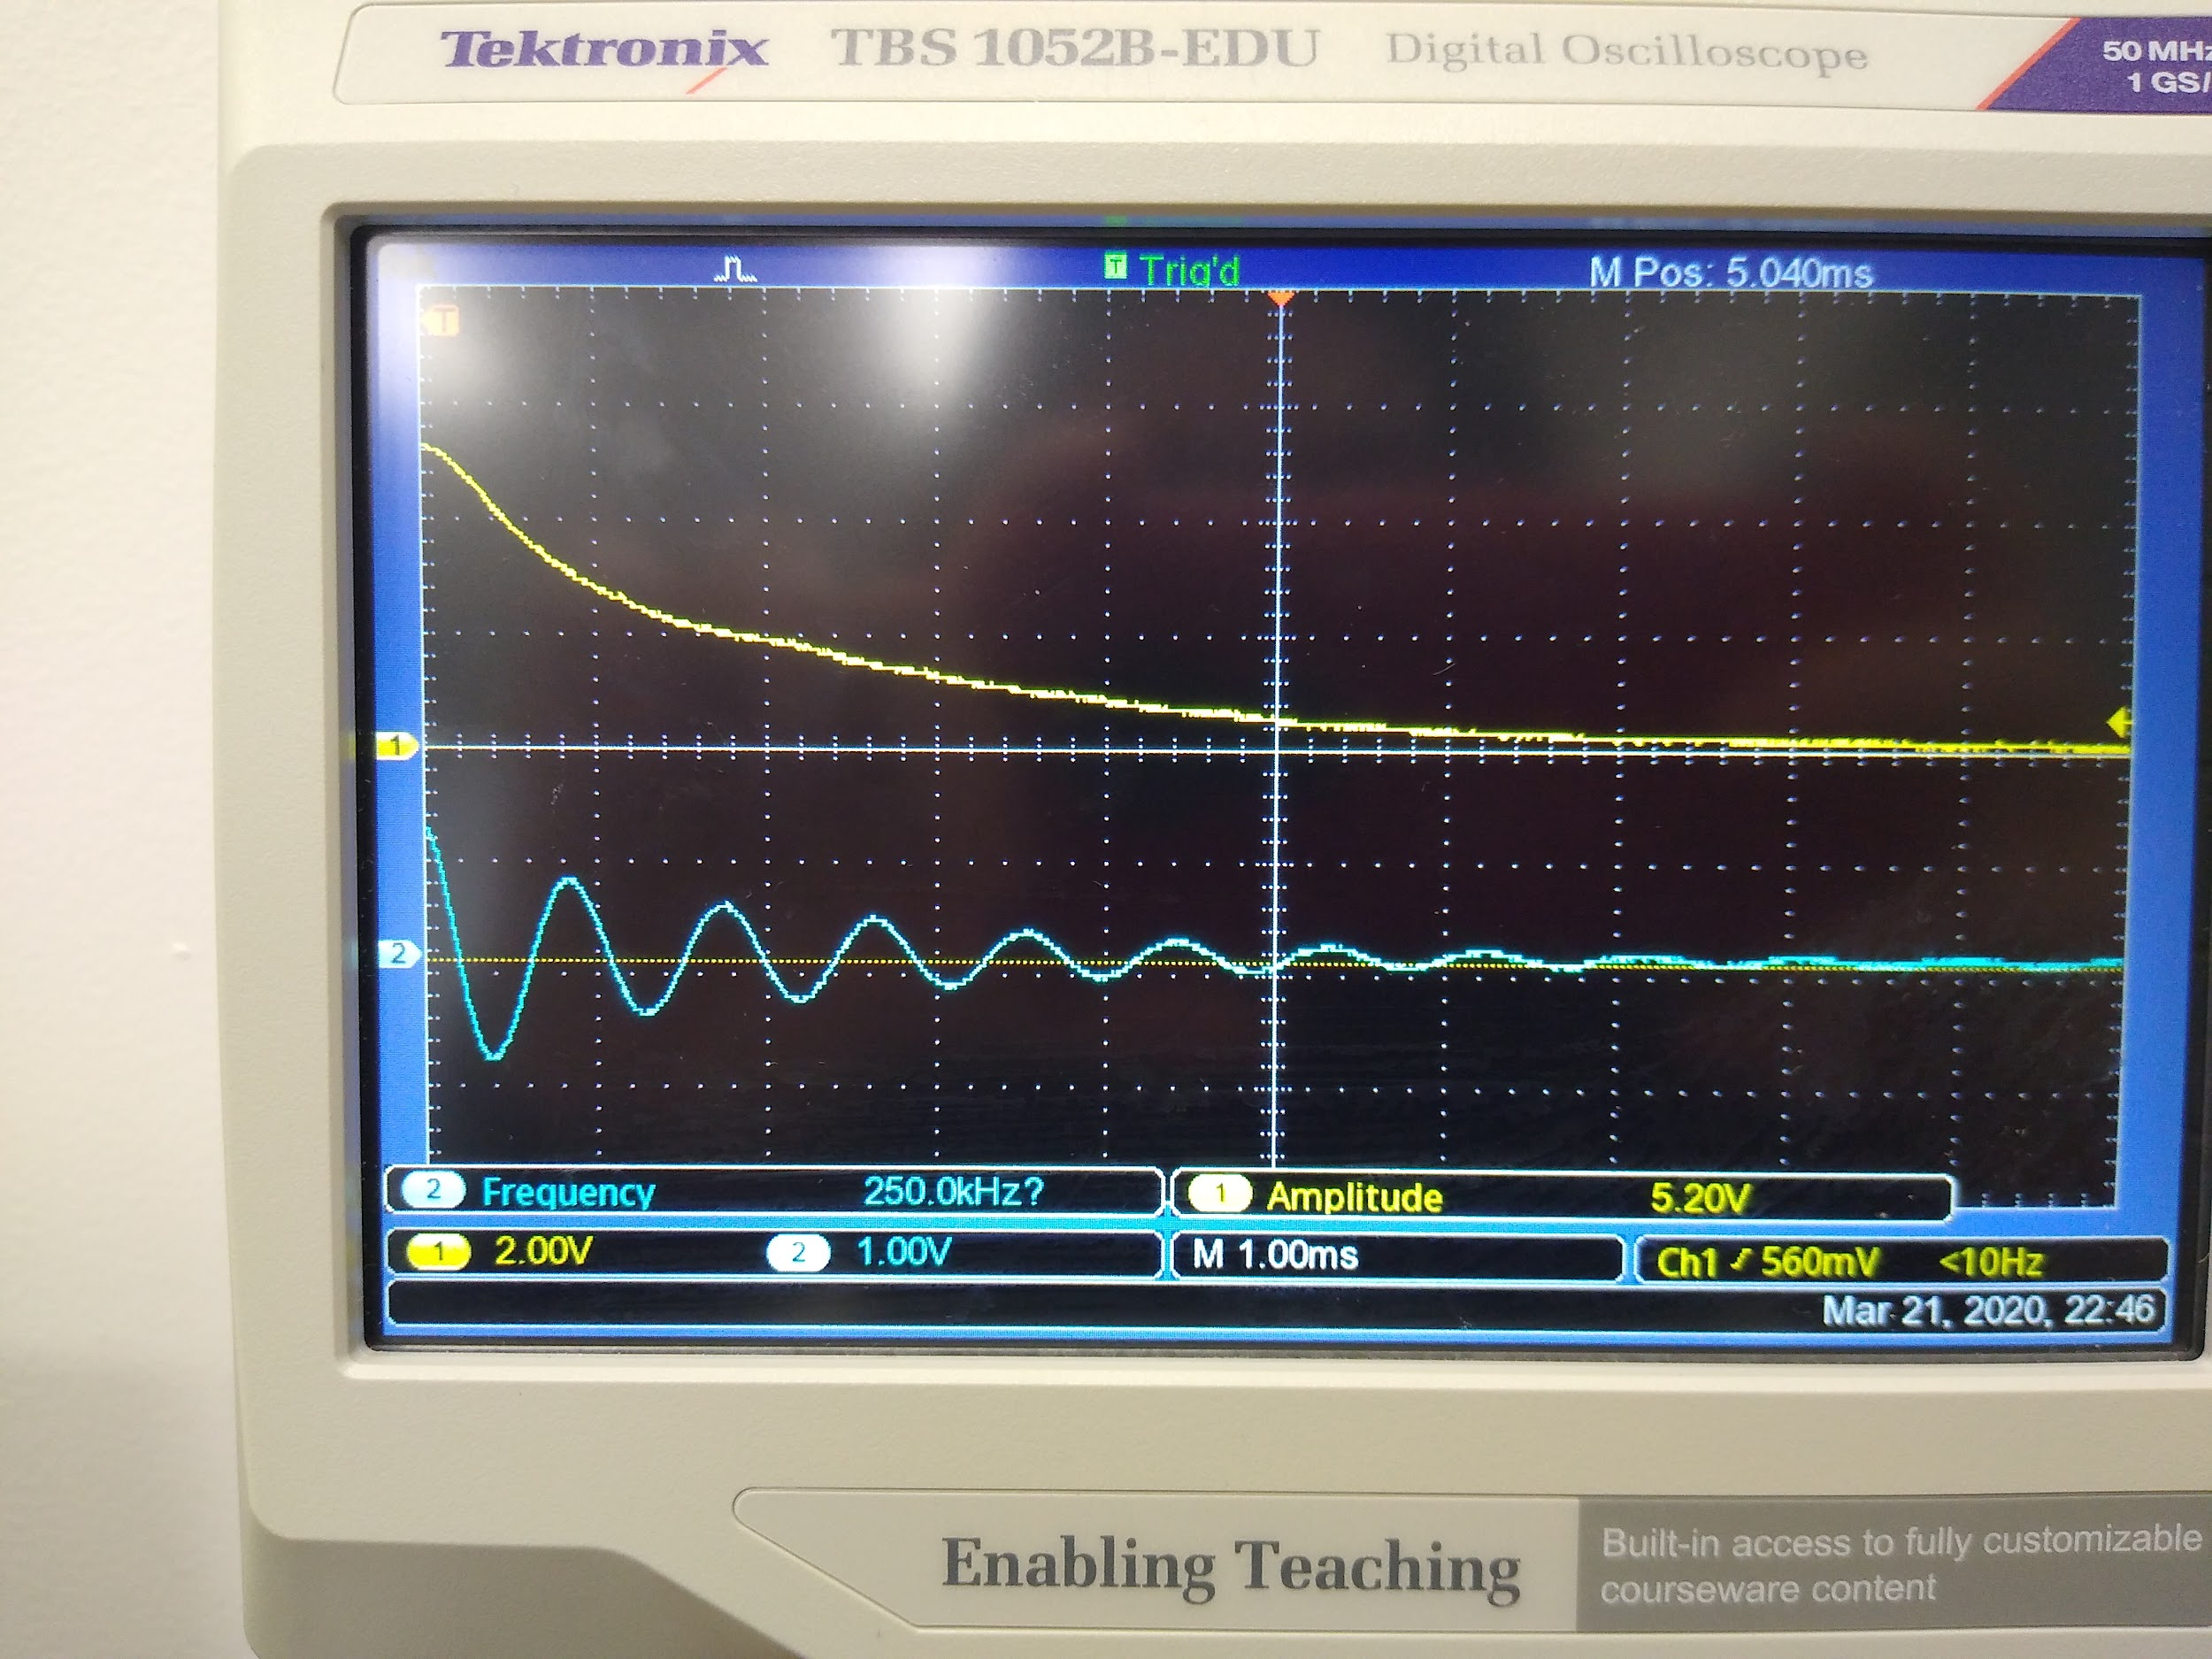

1. If Sample A has a much longer T2 time than Sample B, what can you say about the local magnetic environments of Sample A in comparison to Sample B?

## Observation Experiment: T1 Relaxation - Guided Inquiry Questions

1. Turn off relaxation (by setting 'T1' and 'T2' both to infinity), initialize the spin-state, and then knock the spins down into the x-y plane using a hard-90° pulse. Now change ‘T1’ to some finite value. Observe, sketch, and describe what happens.
2. You may have noticed that it is impossible to set 'T2' larger than 'T1'. This is not a bug in the simulator, but turns out to be a physical fact in MR experiments: T2 ≤ T1. That means it may be difficult to fully disentangle the two from each other, but thinking about the difference in the spin dynamics compared with the T2 relaxation observed above, how does T1 relaxation contribute to the decaying MR signal (|Mxy| and Mx)?
3. If T2 relaxation is also called transverse (xy) relaxation, what might be a good name for T1 relaxation?
4. Given the description of what causes T1 relaxation versus T2 relaxation, why do you think the T1 time is always longer than T2?
5. Describe the magnetic environment that would be necessary for T2 to be equal to T1.
6. We can only acquire signal along the transverse (xy) plane, but T1 is most easily determined by plotting Mz at different time points. How might we acquire the Mz information? *Hint: The first point of an FID experiment is essentially the Mz value right before the hard-90° pulse.*

## Application Experiment: Which sample has the longest T1? - Guided Inquiry Questions

1. How would the amplitude of the FID change if you ran the experiment with a longer repetition time (TR)? Would a sample with longer T1 time or shorter T1 time have the largest change in amplitude when going from short TR to slightly longer TR times?
2. Describe an experimental procedure you can use to compare the T1 times of two samples. Include a pulse sequence for your experiment/s.

**Once you are happy with your experimental procedure, perform your experiment with the provided samples or check out the experiment we performed and the data we collected to determine which sample has the longest T1 time.**

## Reflection Questions

1. What will happen to your MR signal if you choose a repetition time (TR) that is much shorter than the T1 time for your sample?
2. Will using a TR time that is too short impact the measured T2 time?

Below is a plot of the T1 curves for brain tissue compared with cerebrospinal fluid (CSF). You should use this plot to answer the following questions.

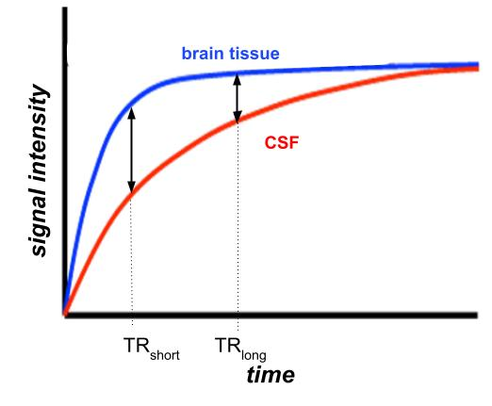

1. Which has the longer T1 time, brain tissue or cerebrospinal fluid?
2. You are designing a T1-weighted MRI pulse sequence that needs to highlight brain tissue from the surrounding cerebrospinal fluid. Looking at the T1 curves provided, which of the TR times (TRshort or TRlong) would be a better choice? Why?

## Follow this rubric to assess your work for this module:

| **Scientific Ability** | **Adequate** | **Needs improvement** | **Inadequate** | **Missing** |
| --- | --- | --- | --- | --- |
| **Is able to differentiate *T*1 and**  ***T*2 relaxation mechanisms for signal decay** | A reasonable explanation is made for the different T1 and T2 relaxation mechanisms for signal decay. | The explanation for the different T1 and T2 relaxation mechanisms for signal decay uses flawed reasoning, is vague, or incomplete. | The explanation for the different T1 and T2 relaxation mechanisms for signal decay contradicts the observed patterns. | No attempt is made to explain the different T1 and T2 relaxation mechanisms for signal decay. |
| **Is able to evaluate and make a judgment about the design and results of an application experiment by direct comparison with their own solution or conceptual understanding** | An evaluation and judgment of the design and results of the application experiment is given with logical and correct justifications compared with their own solution or conceptual understanding. | An evaluation of the experimental design and judgment of the results of the application experiment is made, but the justification provided may be flawed or incomplete. | An evaluation of the experimental design and judgment of the results of the application experiment is made, but no justification is provided. | No meaningful attempt is made  to evaluate or make a judgment about the design or results of the application experiment. |
| **Is able to choose correct experimental parameters to optimize**  **T1 contrast for different samples** | All experimental parameters to optimize T1 contrast for different samples are correctly identified. | Most of the experimental parameters to optimize T1 contrast for different samples are correctly identified. | An attempt is made, but most of the experimental parameters to optimize T1 contrast for different samples are incorrectly identified. | No attempt is made to identify the experimental parameters to optimize T1 contrast for different samples. |